PROJECT DESIGN PHASE-II TECHNOLOGY STACK (ARCHITECTURE & STACK)

|  |  |
| --- | --- |
| DATE | 18 OCTOBER 2022 |
| TEAM ID | PNT2022TMID08727 |
| PROJECT | IOT BASED SMART CROP PROTECTION SYSTEM FOR AGRICULTURAGRICULTURE |
| MARK | 2 MARK |

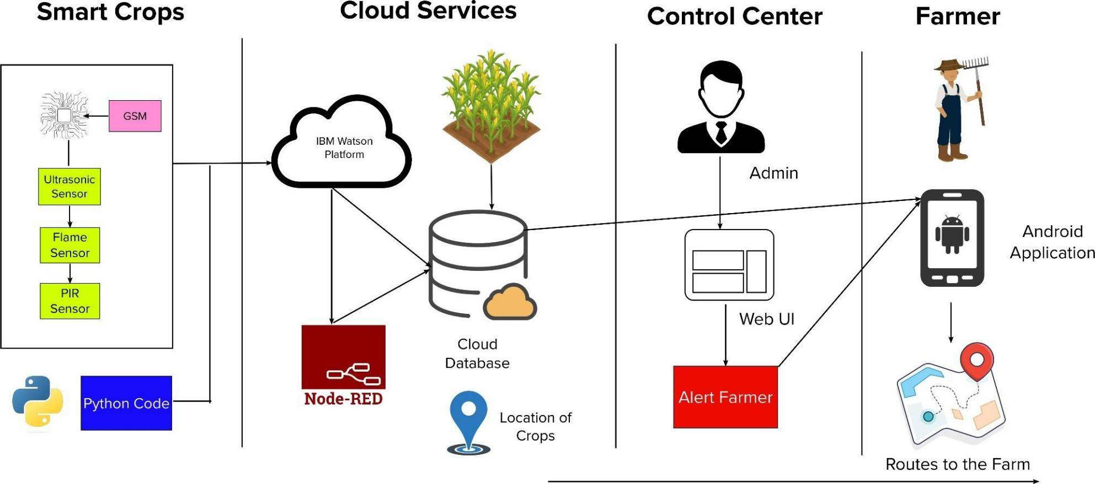

`

**TABLE-1 : COMPONENTS & TECHNOLOGIES:**

|  |  |  |  |
| --- | --- | --- | --- |
| **S.NO** | **COMPONENT** | **DESCRIPTION** | **TECHNOLOGY** |
| 1. | Arduino Uno | The Arduino Uno is an open-source microcontroller board based on the Microchip ATmega328P microcontroller. | Arduino programming itself is done in **C++.** |
| 2. | Application Logic-1 | Logic for Ultrasonic sensor data. | C++/Python |
| 3. | Application Logic-2 | Logic for Flame sensor data. | C++/Python |
| 4. | Application Logic-3 | Logic for a PIR sensor data | C++/Python |
| 5. | GSM | The Arduino GSM shield allows an Arduino board to connect to the internet, send and receive SMS, and make voice  calls using the GSM library. | C++/Python |
| 6. | Cloud Sever | Application deployment on Local System / Cloud | IBM Watson IoT Platform, Node Red |
| 7. | Cloud Database | Database Service on Cloud | IBM Watson IoT platform, Cloudant DB |
| 8. | User Interface | How user interacts with application to alert the Farmer. | HTML, CSS, JavaScript , Python etc. |
| 9. | External API-1 | Purpose of External API used in the application to locate the crops. | Google Maps Geolocation API |

**TABLE-2: APPLICATION CHARACTERISTICS:**

|  |  |  |  |
| --- | --- | --- | --- |
| **S.NO** | **CHARACTERISTICS** | **DESCRIPTION** | **TECHNOLOGY** |
| 1. | Open-Source Microcontroller | Arduino Uno is used to make the IoT device | C++/Python |
| 2. | Security | Encryption/Decryption used for security purpose | GSM, Python |
| 3. | Scalable Architecture | New features can be added. | Node Red |
| 4. | Availability | Web application can be accessed from anywhere | IBM Watson IoT Platform, HTML, CSS,JavaScript |
| 5. | Performance | All Farmers can access the application at same time | Cloudant DB, IBM Watson IoTPlatform |